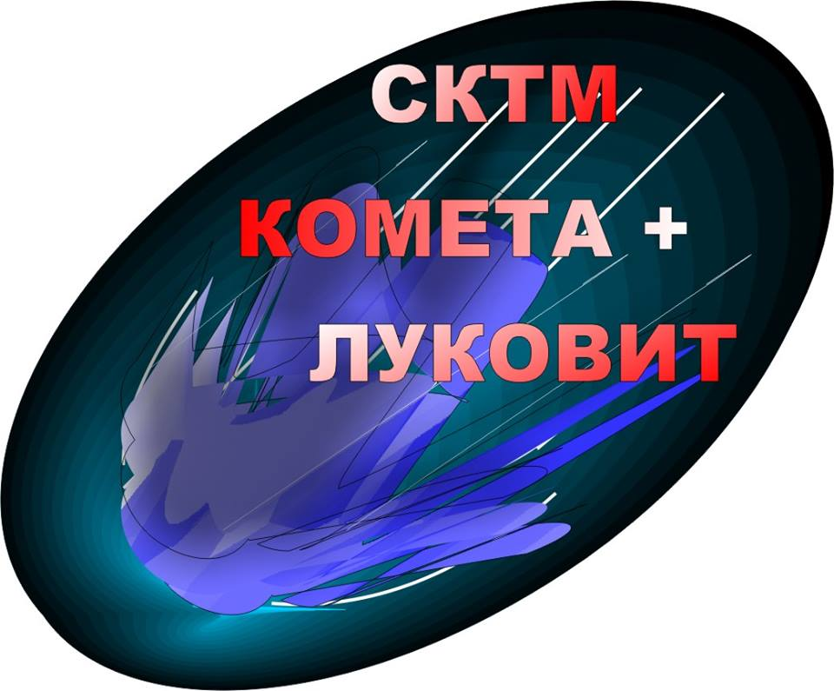
BULGARIAN TABLE TENNIS FEDERATION
VIth ANNUAL INTERNATIONAL
OPEN TABLE TENNIS TOURNAMENT
“MIHAIL CHOLAKOV”
LUKOVIT

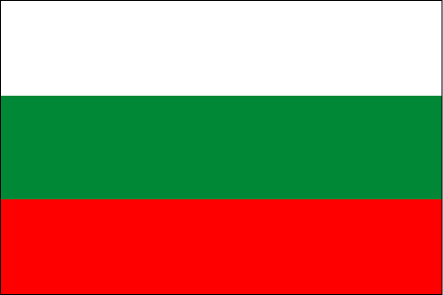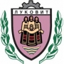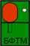
PROSPECTUS

This table tennis tournament is an official competition approved by the Bulgarian Table Tennis Federation.

Organizer Table Tennis Sports Club “Kometa +”, Lukovit

Date 03 - 04 December 2016

Venue Bulgaria, the town of Lukovit (100 km north-east of Sofia)
Sports hall “Hristo Botev”

Events The Tournament will include the following competition:

- Tournament for men veterans
Categories:
30 - 40 years
40 - 50 years
50 -59 years
60+
- Tournament for kids under 14 years of age
In all disciplines only individual tournament will be held.
Please, point out in which category and competition you will take part.

Participants The championship is open for all National Federations and Regional Sports Clubs. There is no restriction of the number of participants from each Federation. Female participants are allowed to take part in the male disciplines

Entry free Each participant has to pay:

Men Veterans - 20 BGN (7.5 €) per player
Kids - 5 BGN (2.5 €) per Player

Schedule of events Saturday 03.12.2016
09:00 – DRAWS 30-39
10:00 – KIDS
10:00 – 11:30 Veterans Groups – 30 – 39г.
11:30 – 13:00 Veterans Groups – 40 – 49г.
13:00 – 14:30 Veterans Groups – 50 – 59г
14:30 – Официално отриване на турнира
14:40 – KIDS Knockout rounds till FINAL (Included)
14:40 – 16:00 Veterans Groups 60+
16.00 - Veterans knockout rounds till ½ Final
KIDS Awarding ceremony.
20:30 – Diner – Everybody is invited on sponsors costs !

Sunday 04.12.2016
10.30 - 11.00 - All Veterans Knockout rounds ½ FINAL
11:30 - 12:00 – FINALS (40 – 49 г.); (50 – 59 г.); (60+)FINAL
12:00 Veterans 30 – 39 г.Final

The Event Organizer reserves the right to make any changes in the schedule of the events for better organization and optimal use of the capacity of the hall.

Playing System According to the number of participants in each category there will be games in preliminary groups. The first two players from each group of controlled draw will be distributed in a scheme for elimination after one loss. All matches for veterans and kids will be played in best of five.

Applications Final Entry Form not later than 27 November 2016
Vladimir Petkov
GSM +359884762115
Е-mail: sktm_kometa@yahoo.com
All applications will be submitted by E-Mail and has to include the name of the competitor, category and competition in which he will take part, and request for a hotel reservation.

Draw Veterans
Friday : 19:00 At Hotel - Restorant Diplomat Park
KIDS - 09:00 on Saturday at playing hall.

Accommodation Participants will be accommodated in Hotel “Diplomat Park” Lukovit
Double room / breakfast incl. /- 23 € per room per day (11.5 € per Person)
Single room / breakfast incl. / 11.5 €
Requests for accommodation will only be accepted on the E-Mail, together with the application form or on tel: +359 884 762 115 - Vladimir Petkov
After 25 November 2016 hotel reservations will be possible only if any rooms are available!

Equipment | Ball TSP *** Plastic (white)
Prizes Medals and Diplomas for all categories
Cups for the winners in all categories
Cash prizes:
1. Gifts for all participants
2. Cups for all the winners.
3. Medals for the first 3 places
4. Material Prices:
4.1 Veterans – (30-39)
1-st place – 600 BGN. + Anzung
2-nd place – 300 BGN. + Anzung
3-rd place – 200 BGN. + Anzung
4-th place – 200 BGN. + Anzung
4.2 Veterans (40 – 49 г.); (50 – 59 г.); (60+)
1-st place – 500 BGN. + Anzung
2-nd place – 200 BGN. + Anzung
3-rd place – 100 BGN. + Anzung
4-th place – 100 BGN. + Anzung

4.3 Kids 14 years of age
1-st place – Shirt ,Racket Case ,Towel ,Anzung
2-nd place – Racket Case ,Towel ,Anzung
3-rd place – Racket Case, Anzung
4-th place – Racket Case, Anzung
5-th place – Towel ,Anzung
6-th place – Towel ,Anzung
7-th place – Towel ,Anzung
8-th place – Towel ,Anzung

If the number of participants in this tournament is insufficient, the Event Organizer has the right to reduce the amount of the cash prizes on the account of the more numerous categories.

Badges and Anthems The foreign sports delegations are requested to have with them their national flags and anthems for the award ceremony

Event Organizer, Referee
Event Organizer – Vladimir Petkov
Head Referee – Vladimir Lalev
Secretary – Kliment Todorov

